**Functional design <Geef de bedrijfsnaam van de klant op.>**

**Project:** <Geef de projectnaam op.>

**Client:** <Geef de bedrijfsnaam van de klant op.>

**Projectnumber:** <Geef het projectnummer op.>

**Auteur:** <Geef de auteursnaam op.>

**Date:** <Geef de datum op wanneer het document opgesteld is.>

**Version:** <Geef het versienummer op.>

The undersigned declare their agreement with the content of this functional design.

**Client Projectmanager**

***Initial Seen: Initial Seen:***

Date: <Geef de datum op.> Date: <Geef de datum op.>

Place: <Geef de plaats op.> Place: <Geef de plaats op.>

Functional design document

Inhoud

PROJECT MANAGEMENT 2

PROJECT DETAILS 2

PROJECT DESCRIPTION 2

REQUIREMENTS 3

USE CASE DIAGRAM AND SCENARIOS 4

WIREFRAMES 4

PERSISTENT DATA 5

APPENDICES 6

APPENDICE A 6

# PROJECT MANAGEMENT

We are Thomas Godding and Eddie Beelen. Eddie is the project leader. Still we discus everything together and we have both input in the project. We will communicate in the classroom and with discord. We meet almost every day on school.

# PROJECT DETAILS

Our project is called new TI. Our client is Peter Nocker. The contractor is Eddie Beelen and Thomas Godding.

# PROJECT DESCRIPTION

We are working together on this project. Even if Eddie is the project leader we decide together what is coming in the project and what not. The main intention of this project is to learn to use a whole new API and make a full working application around it.

# REQUIREMENTS

Must

* The application is connected to the twitch API.
* You can search information from multiple streamers.
* Drag and drop layout.
  + Every streamer information can be dragged and dropped separately.
* Adding streamers through a search bar
* You can select which data u want from a streamer
  + Chat
  + Stream activity
  + Stream info
* Making application in C# and/or Web
* Downloadable exe (if C#)
* Website with downloadable exe and inviting look
* Application guide
* About

Should

* Local save with settings you use / save user settings as last.
  + Which streamer you have opened
  + What information you have opened
* Saving layouts you want to use
  + Which streamer
  + What you are seeing off this streamer
  + The position of each block (drag and drop) information
* Video and Documented tutorial

Could

* Linking your own Twitch
* Log in

Won’t

* Errors
* Bad design
* Use without drag and drop

# USE CASE DIAGRAM AND SCENARIOS

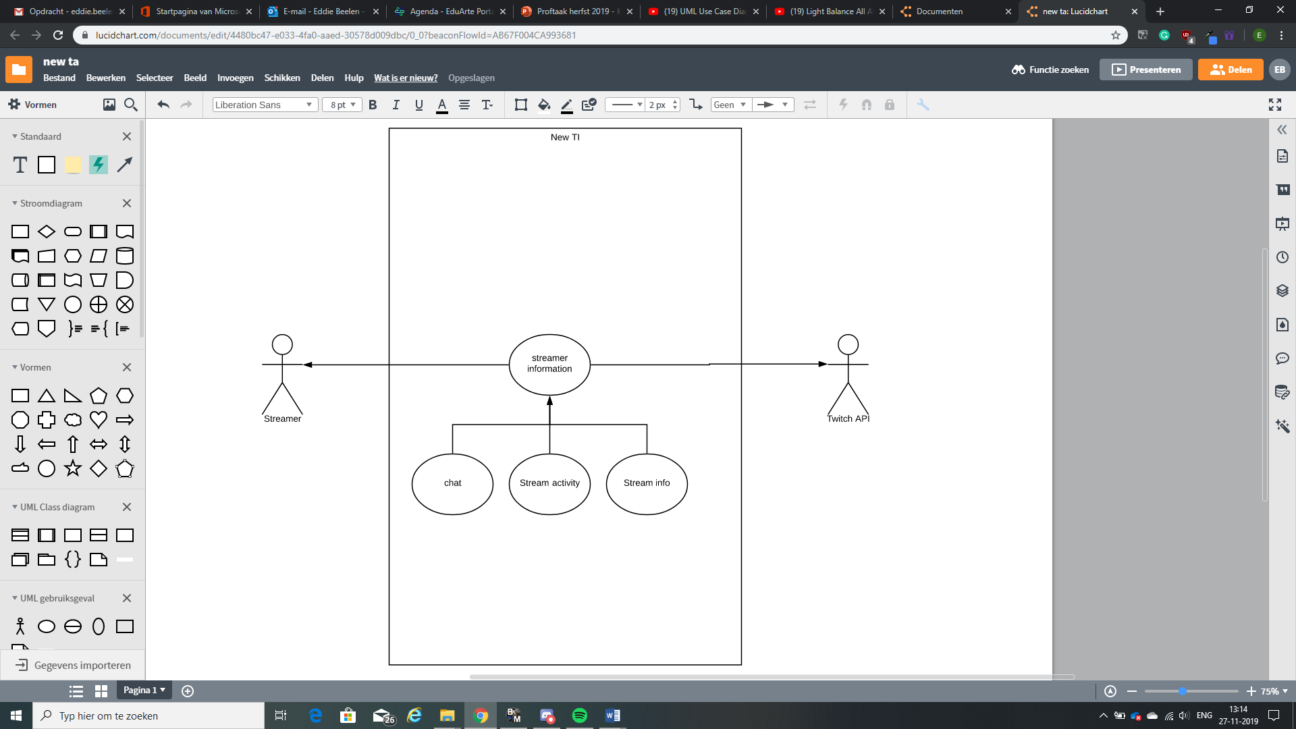

# WIREFRAMES

Sketch the primary forms you will use in your system. Where will be which information.

Example:

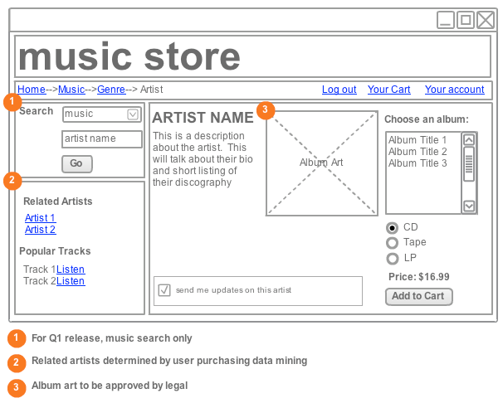

You should check if the wire frames cover ALL the use cases ( use a matrix to show that)

# PERSISTENT DATA

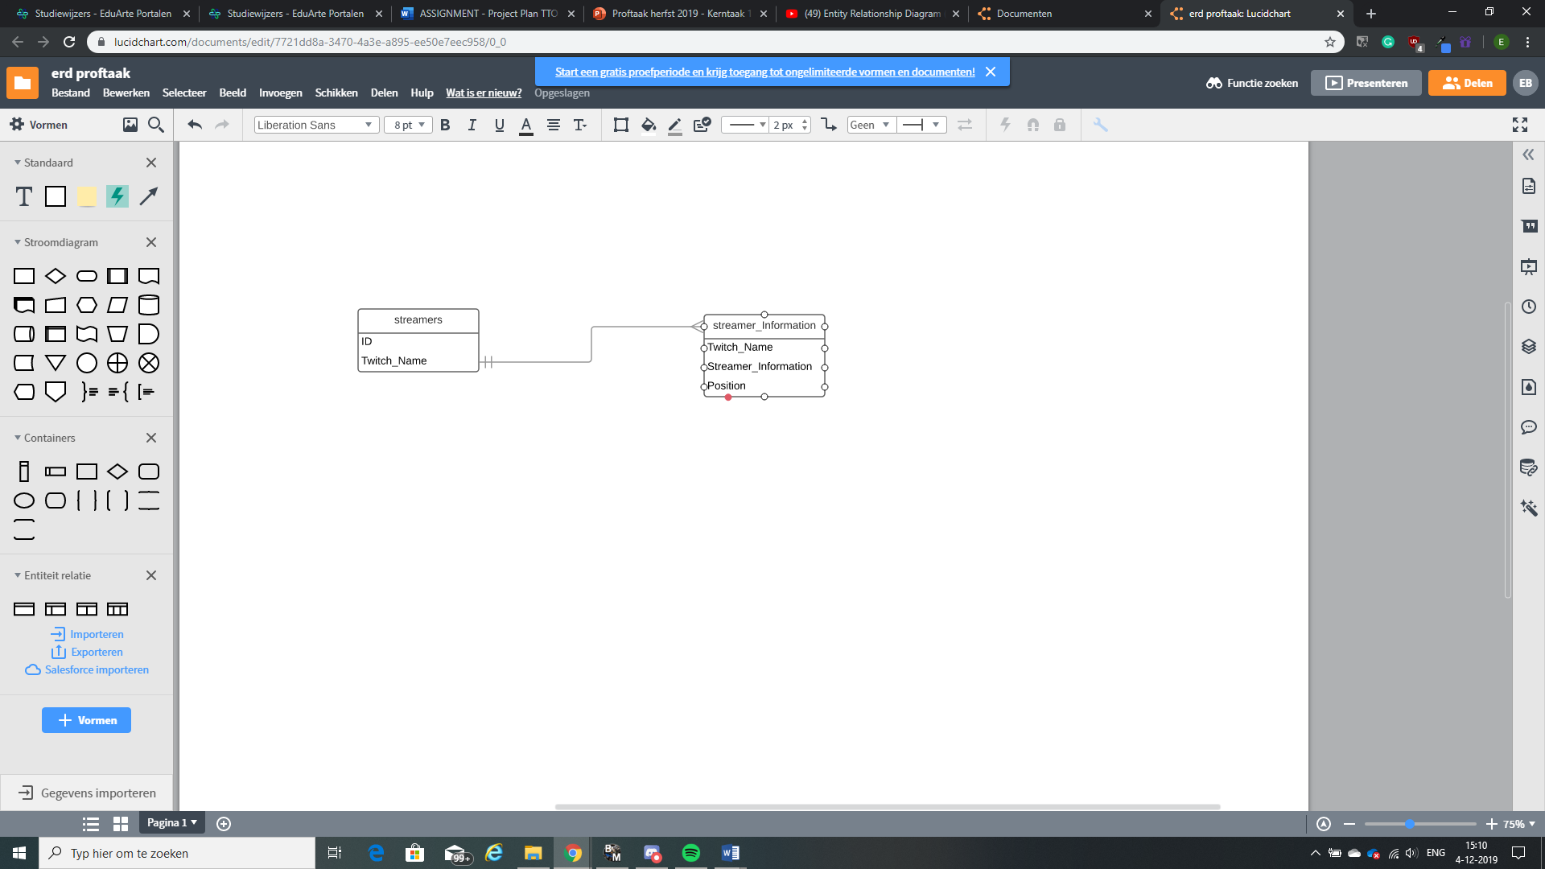

# APPENDICES